Easy-to-Do Fundraising Tips for Success!

Many people find it hard to get started fundraising. We’re here to help! Here are some tips from real individuals who have achieved great success fundraising for CCHS AND a flyer at the end you can fill out that will get you well on the way to successfully raising whatever you put your mind to!

How much? Give yourself a goal that you believe is a little out of your comfort zone. When you reach your goal, generally people will stop giving. If you’re going for the grand prize, you might want to set it between $3500 and $4000. If you aren’t going for the grand prize, here are some goals you could shoot for:
- $250 will cover the cost of:
  - Spay or Neuter 7 animals
  - Provide 5 dog beds
  - Feed the animals in the shelter for ONE week
  - Keep the shelter open for 2 hours
  - Provide vaccinations for 15 animals
- $500 will cover the cost of:
  - Spay or Neuter 15 animals
  - Feed the animals in the shelter for TWO weeks
  - Keep the shelter open for 4 hours
  - Feed kittens and puppies bottles and formula for SIX months
- $1000 will cover the cost of:
  - Spay or Neuter 30 animals
  - Feed the animals in the shelter for ONE MONTH
  - Feed kittens and puppies bottles and formula for SIX months
- $2500 will cover the cost of:
  - Keep the shelter open for one whole day!

Set a Time Limit: Give yourself a few weeks - we recommend between two and four - to get your donations in.

Get Personal: The most effective ways to ask are personal. Try emailing or calling people individually, and take time to individualize each message for each person
.
Why are you fundraising? Answer that question so you can tell people why you are so passionate to fundraise for the Humane Society. Did you have a good experience with an adopted animal from us? Do you have a heart for animals? Do you want to help bring humane education to thousands in our community? Here are some ways that we help each year that could help you answer that question, if you don’t have a personal passion. Keep your passion and your reason center-stage, and you will surely make your goal. At CCHS, because of donations, here’s our community impact:
- Find Forever homes for over 1500 animals a year!
- Keeping the only open-admission shelter in our area open: Open-admission means we take any owner-relinquished companion animal regardless of age, medical condition, or adoptability.
- Almost 4,000 children and adults every year are educated on humane care and treatment of animals
- Ending pet homelessness by helping families in need
  - Last year, over 100 families received low-cost vaccines
  - Last year, over 400 low-cost spay/neuter surgeries were given

Get on Social Media: Post why you are fundraising with your fundraising page multiple times to your social media outlet of choice - people need to see your posts multiple times to get them to donate. (try linkedin, nextdoor.com, Facebook, Twitter + Instagram) Ask them to share your post to their page for even greater reach.

Collect offline: Create a flyer (you can use the one below) and get knocking! Customize the flyer to ask your neighbors and coworkers personally. What do you do with Offline Donations? Send their donations to us. Please have them make checks out to CCHS (or the Champaign County Humane Society.) (FYI Our address is 1911 East Main Street, Urbana, IL 61802). Please have them write on the check (or on a note) your name and Mutt Strut and include their phone number or email address in case we have any questions.

Bribe coworkers: Bring goodies into work and ask your coworkers for a donation in exchange for the treat.

Make it a contest: Post on Social Media that anyone who makes a donation in the next week will be entered in a drawing to win one of your signature dishes / paintings / homemade bird houses, etc.

Show them Trust: Let all your potential donors know that CCHS is a Charity Navigator 4 Star rated charity so people can feel confident in their tax deductible contributions.

HI! My name is _______________________________ and I am raising money for the Champaign County Humane Society! I’m participating in their dog walk, called the Mutt Strut, this May. Here’s why I’m raising money for the Champaign County Humane Society:
__________________________________________________________________________________________
__________________________________________________________________________________________
__________________________________________________________________________________________

My Fundraising goal is:______________________
This will help the Humane Society accomplish this:_________________________________________________

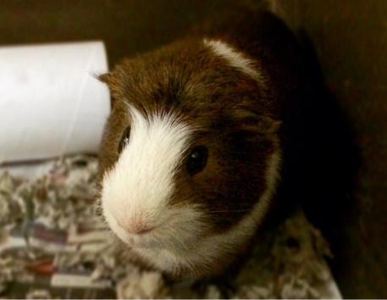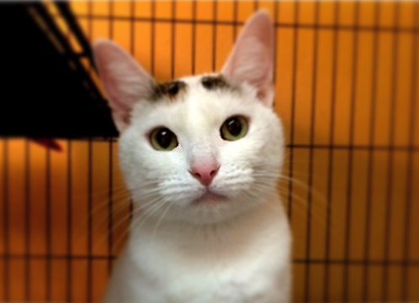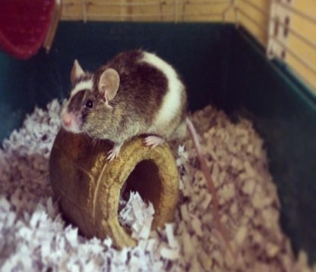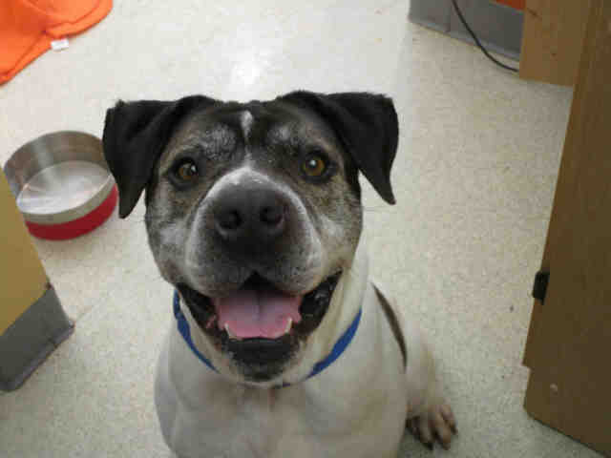

Will you give to my fundraising page for Champaign County Humane Society (CCHS)?
- Credit Card: If you want to give by credit card, here is the web address for my page: _____________________________________________________________________
- By Check or Cash: (Checks made out to CCHS)

TO NOTE:
- ALL Checks and Cash donations need to be into me by April 28) (so I can send them in) contributions are tax deductible!
- Give with confidence! CCHS is a 501(c)3 nonprofit and a Charity Navigator 4-Star rated Charity! (You can go to charitynavigator.org for more information)
- You make ALL the difference! CCHS doesn’t receive any local, county, state, or federal funding. We rely on individual donations from generous donors, like you!
- JOIN ME! Together we can make a difference in the lives of homeless animals in our area!
- You can go to www.cuhumane.org for more information about CCHS

MUTT STRUT 2017
_________________________’s COLLECTION SHEET

My email:_______________________________ My phone: _____________________________________

Please note: All gifts of checks or cash must be in the mail to CCHS by April 28
to be eligible to be counted in my fundraising page totals!

Name | Address | Email | Amount

